EE3060 Probability – Proposed questions and answers

Question 1:

A point Y is randomly selected from [0,2], and the other point X is randomly selected from [0,Y].

Find the probability density function of X.

Answer 1:

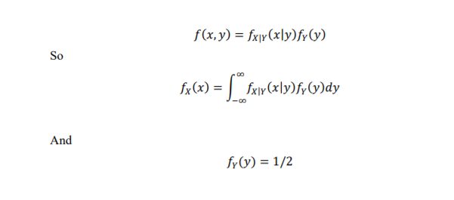

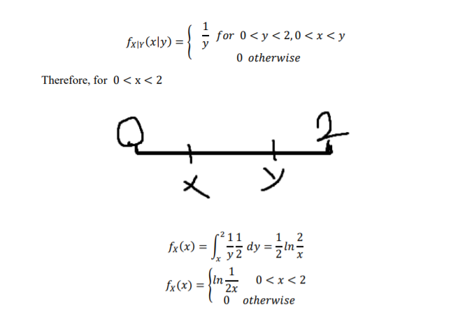

Question 2:

Given $fx\left(x\right)=\left\{\begin{aligned}x, 0<x≤1 \\ 2-x, 1<x≤2 \\ 0, otherwise\end{aligned}\right.$,

1. Find $P(\frac{1}{2}<X<\frac{3}{2})$
2. Find $E[X]$, $Var[X]$
3. Find CDF of $f\left(x\right)$

Answer 2:

$P\left(\frac{1}{2}<X<\frac{3}{2}\right)$

$$=\int_{\frac{1}{2}}^{\frac{3}{2}}{f\left(x\right)dx=\int_{\frac{1}{2}}^{1}{xdx+\int_{1}^{\frac{3}{2}}{\left(2-x\right)dx} } }$$

$$= \frac{3}{8}+\frac{3}{8}=\frac{3}{4}$$

$E\left[X\right]=\int_{0}^{2}{xf\left(x\right)dx=\int_{0}^{1}{x*xdx+\int_{1}^{2}{x*\left(2-x\right)dx} } }$

$$={\left.\frac{x^{3}}{3}\right|}_{0}^{1}+{\left.x^{2}-\frac{x^{3}}{3}\right|}_{1}^{2}= \frac{1}{3}+\frac{2}{3}=1$$

$$E\left[X^{2}\right]=\int_{0}^{2}{x^{2}f\left(x\right)dx=\int_{0}^{1}{x^{2}*xdx+\int_{1}^{2}{x^{2}*\left(2-x\right)dx} } }$$

$$={\left.\frac{x^{4}}{4}\right|}_{0}^{1}+{\left.\frac{{2x}^{3}}{3}-\frac{x^{4}}{4}\right|}_{1}^{2}= \frac{1}{4}+\frac{11}{12}=\frac{7}{6}$$

$$Var\left[X\right]=E\left[X^{2}\right]-E\left[X\right]=\frac{7}{6}-1=\frac{1}{6}$$

1. For x<1 $\int_{0}^{x}{xdx=\frac{1}{2}x^{2}}$

For 2>x>=1 $\int_{0}^{1}{xdx+\int_{1}^{x}{2-xdx}=\frac{1}{2}+({\left.2x-\frac{x^{2}}{2})\right|}_{1}^{x}}$

$$=2x-\frac{x^{2}}{2}-1$$

For x>=2 $\int_{0}^{1}{xdx+\int_{1}^{x}{2-xdx}=1}$

CDE = $\left\{\begin{aligned}0, x≤0 \\ \frac{1}{2}x^{2}, 0<x≤1 \\ 2x-\frac{x^{2}}{2}-1, 1<x≤2 \\ 1, x>2\end{aligned}\right.$

Question 3:

Let Y=sin(X), where X is uniformly distributed in the interval (0,2π)

Find the pdf of Y

Answer 3:

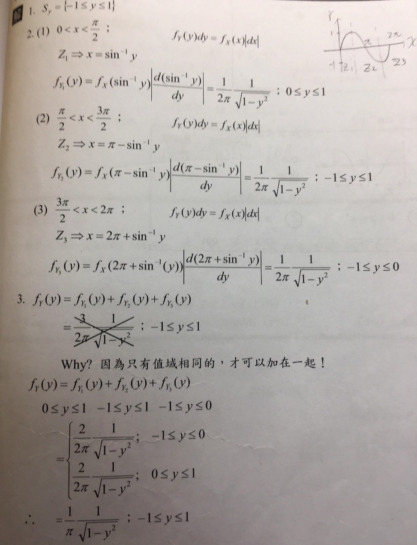

Question 4:

Let X be a random number from (0,1). Find the probability density fuction of Y=1/X

Answer 4:

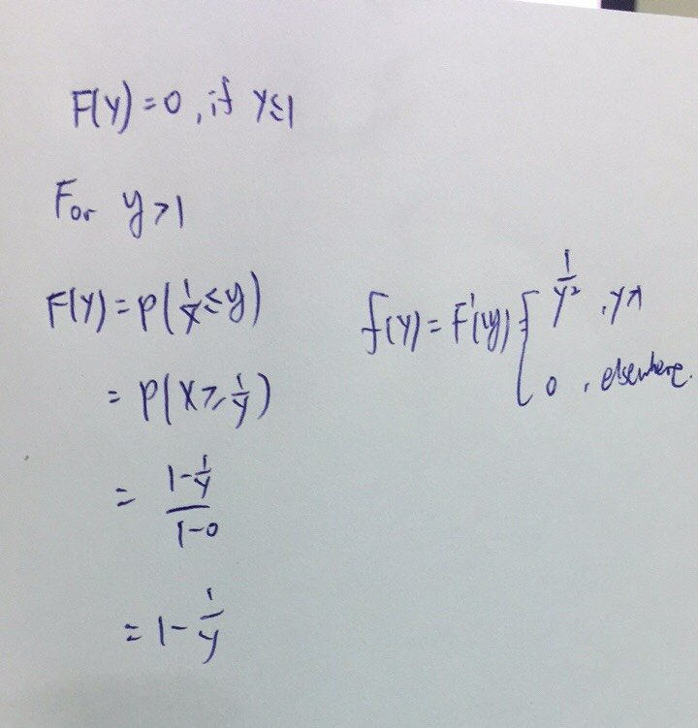

Question 5:

Q:The temperature at NTHU city is modeled as normal random variable with mean and standard deviation both equal to 30C(Celsius).

A delicate bomb is designed to boom at 113F(Fahrenheit).What is the probability that the bomb explode at a randomly chosen time?

Answer 5:

